**Types of Binary Trees:**

There are five types of binary trees.

1. **Full Binary Tree:**

It is the type of binary tree which has either two children or no children. It means that that a parent is parent of two children or it is a leaf. If a node has only one child it is not a full binary tree. The number of leafs is equal to number of internal nodes plus one.

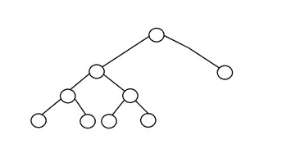

1. **Complete Binary Tree:**

It is type of binary tree in which all the nodes are completely filed with nodes except the

Lowest level of the tree. In this type of tree the last node should reside on the left side.

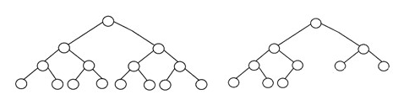

1. **Perfect Binary Tree:**

A perfect binary tree should must have two children and every lead should be on the same depth. A perfect Binary tree with height ‘h’ has 2h-1 nodes.

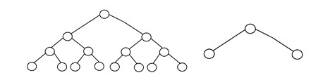

1. **Balanced Binary Tree:**

A binary tree is balanced if its height is O(logN), where ‘N’ is the number of nodes. In this case the height of left and right node should only vary by only one.

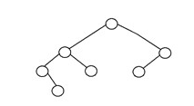

1. **Degenerate Binary Tree:**

A binary tree is said to be degenerate if its internal node has only a single child. Such trees are similar to linked-list in functionality.

